EE5351_DIGITAL VIDEO CODING

DIGITAL WATER MARKING ASSIGNMENT

NAME: PAVAI ARCHIMEDES

ST ID: 1001233996

MATLAB PROGRAM:

clc;

close all;

clear all;

lenaimage=imread('lena512.bmp');

uta_logo=imread('uta_logo.gif');

vis_logo=lenaimage;

alpha=[.25,.5,.75,1];

figure;

for i=1:4

Visible=((1-alpha(i)).*abs(lenaimage(425:512,213:512)))+(alpha(i).*uta_logo);

vis_logo(425:512,213:512)=Visible;

Ret_logo= (vis_logo-((1-alpha(i))*lenaimage))./alpha(i);

subplot(2,4,i);

imshow(vis_logo);

title({'IMAGE FOR RVC= ',num2str(alpha(i))});

subplot(2,4,i+4);

imshow(Ret_logo(425:512,213:512),[]);

title({'IMAGE FOR RVC= ',num2str(alpha(i))});

end

inv_logo=lenaimage;

Invisible=(4*uint8(lenaimage(425:512,213:512)/4))+(uta_logo/64);

inv_logo(425:512,213:512)=Invisible;

fid=fopen('C:\Users\WATER\Desktop\d_watermarkimage.img','w');

fwrite(fid,inv_logo);

fid=fopen('dec_image.img');

Dec=fread(fid);

Dec=double(reshape(Dec,512,512));

r_logo=(uint8(Dec)-uint8(lenaimage))*64;

figure;

subplot(2,2,1);

imshow(lenaimage);

title('ACTUAL IMAGE OF LENA');

subplot(2,2,2);

imshow(uta_logo);

title('ACTUAL IMAGE OF UTA LOGO');

subplot(2,2,3);

imshow(inv_logo);

title('IMAGE OF DIGITAL INVISIBLE WATERMARK');

subplot(2,2,4);

imshow(uint8(r_logo(425:512,213:512)));

title('RETRIVED LOGO FROM INVISIBLE WATERMARK');

OMEGA SERVER:

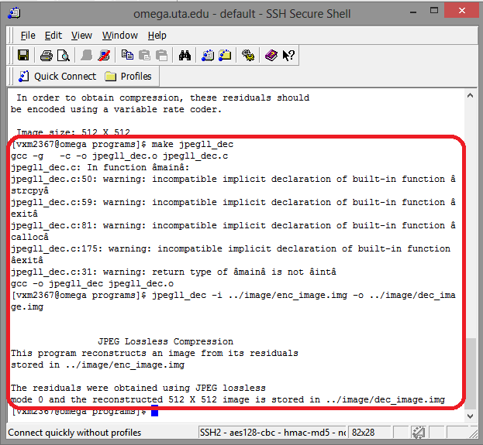

OUTPUT:



